BONAFIDE CERTIFICATE

Certified to be the Bonafide Record of the work done by Master. Chandramouleesvar V of class XII – A in Sri Sankara Senior Secondary School, Adyar during the year 2017-2018.

Dated: Subject Teacher

Submitted for All-India Higher Secondary Practical Examination held in Computer Science Lab at Sri Sankara Senior Secondary School, Adyar.

Dated: Examiner

ACKNOWLEDGMENT

This Project is a result of dedicated effort. It gives us immense pleasure to prepare project report on E-Business.

We would like to sincerely thank our subject teachers Mrs. Revathy and Mrs. Vidyalakshmi for their consultative help and constructive suggestion and for their overall support rendered throughout the project. We would also like to thank our subject Lab Assistant Mr. Jose for his valuable assistance.

TABLE OF CONTENTS

|  |  |  |
| --- | --- | --- |
| **S.No** | **Contents** | **Page No.** |
| 1 | About the Project | 4 |
| 2 | FRAME 1 (Login/Signup) | 5 |
| 3 | FRAME 2 (Login) | 7 |
| 4 | FRAME 3 (Signup) | 10 |
| 5 | FRAME 4 (Movies Selection) | 13 |
| 6 | FRAME 5 (Ticket Dates) | 17 |
| 7 | FRAME 6 (Show Timings) | 21 |
| 8 | FRAME 7 (Seat Selection 1) | 23 |
| 9 | FRAME 8 (Seat Selection 2) | 67 |
| 10 | FRAME 9 (Seat Selection 3) | 108 |
| 11 | FRAME 10 (Card Selection) | 153 |
| 12 | FRAME 11 (Card Details) | 155 |
| 13 | FRAME 12 (Confirmation) | 158 |
| 14 | FRAME 13 (Thank You) | 162 |
| 15 | Backend - MySQL | 163 |
| 16 | Scope for further enhancements | 165 |
| 17 | Bibliography | 166 |
| 18 | Developers | 167 |

About The Project

This is “SPI Cinemas” venture into the world of Movie Ticket Booking. This project if about E-Business. This project has 13 frames and helps you to book movie tickets easily. In each frame different commands and code have been used.

The Front end used for this project is Java Netbeans 8.2 and the Backend used is MySQL.

To resize the JFrame during runtime: (Mandatory Code used in all the JFrames)

public Login_SignUp() {

this.setBounds(400, 100, 500, 500);

initComponents();

Toolkit tk = Toolkit.getDefaultToolkit();

int xsize = 705;

int ysize = 460;

this.setSize(xsize, ysize);

}

FRAME 1: Login – Signup

* If you are an existing user, this page directs you to the Login Frame.
* If you are a new user, this page directs you to the Signup Frame.

Login Frame:

private void jButton2ActionPerformed(java.awt.event.ActionEvent evt) {

Login o = new Login();

o.setVisible(true);

this.dispose();

}  
  
  
Signup Frame:

private void jButton3ActionPerformed(java.awt.event.ActionEvent evt) {

SignUP o = new SignUP();

o.setVisible(true);

this.dispose();

}

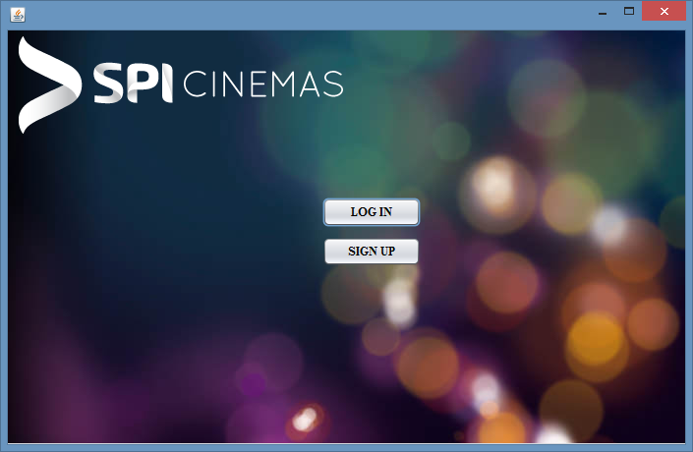

FRAME 2: Login

private void jButton1ActionPerformed(java.awt.event.ActionEvent evt) {

String a = tf1.getText();

String b = pf1.getText();

if (a.isEmpty()==true)

JOptionPane.showMessageDialog(null, "Enter Details");

if (b.isEmpty()==true)

{

{ JOptionPane.showMessageDialog(null, "Enter Details");

}

}

else

{

Movies o = new Movies();

o.setVisible(true);

this.dispose();}

}

try {

String email = tf1.getText();

String pass = new String(pf1.getPassword());

Class.forName("java.sql.Driver");

Connection conn = (Connection) DriverManager.getConnection("jdbc:mysql://localhost/IP_PROJECT","root","password");

Statement st = (Statement) conn.createStatement();

String q = "insert into email values ('"+email+"','"+pass+"')";

System.out.println(q);

st.executeUpdate(q);

}

catch (Exception e)

{

System.out.println(e.getMessage());

}

}

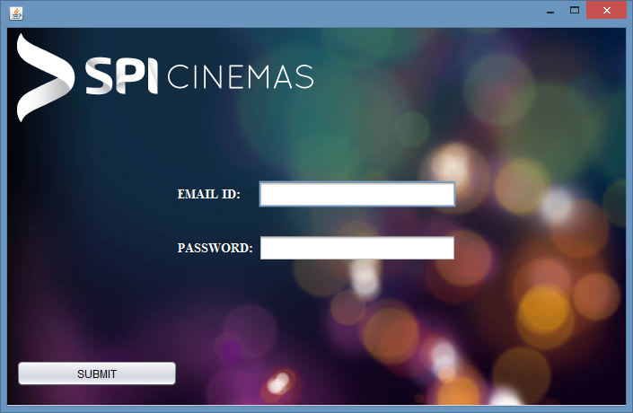

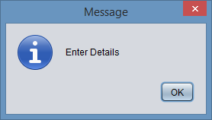

FRAME 3: Signup

- This Page directs you again to the Login Frame.  
  
private void jButton1ActionPerformed(java.awt.event.ActionEvent evt) {

if(cb1.isSelected()==true)

{

Login o = new Login();

o.setVisible(true);

this.dispose();

}

else if(cb1.isSelected()==false)

{

JOptionPane.showMessageDialog(null,"Agreement");

}

try {

String email = tf1.getText();

String name = tf2.getText();

int mob = Integer.parseInt(tf4.getText());

String DOB = tf3.getText()

Class.forName("java.sql.Driver");

Connection conn = (Connection) DriverManager.getConnection("jdbc:mysql://localhost/IP_PROJECT","root","password");

Statement st = (Statement) conn.createStatement();

String q = "insert into New_User values ('"+email+"','"+name+"',"+mob+",'"+DOB+"');";

System.out.println(q);

st.executeUpdate(q);

}

catch (Exception e)

{

String h=(e.getMessage());

h= h.substring(0,9);

if(h.equals("Duplicate"))

{JOptionPane.showMessageDialog(null,"Existing User!!");}

}

}

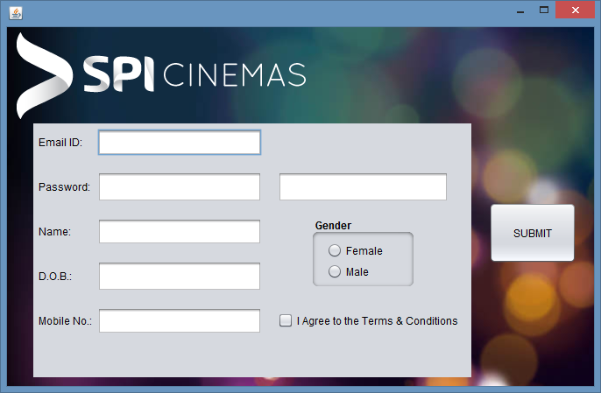

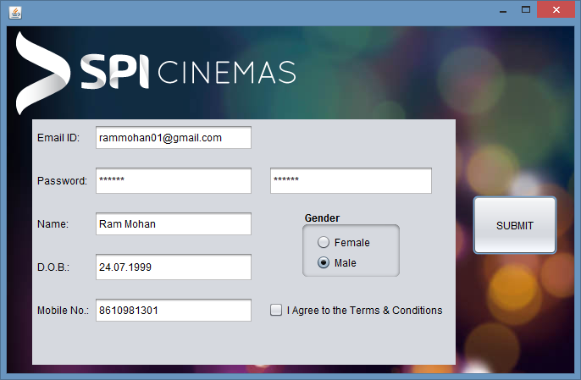

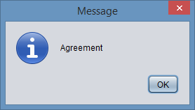

FRAME 4: Movies Selection

private void mersalActionPerformed(java.awt.event.ActionEvent evt) {

Tickets_Dates o = new Tickets_Dates();

o.setVisible(true);

this.dispose();

movie = 1;

}

private void golActionPerformed(java.awt.event.ActionEvent evt) {

Tickets_Dates o = new Tickets_Dates();

o.setVisible(true);

this.dispose();

movie = 2;

}

private void soloActionPerformed(java.awt.event.ActionEvent evt) {

Tickets_Dates o = new Tickets_Dates();

o.setVisible(true);

this.dispose();

movie = 3;

}

private void thorActionPerformed(java.awt.event.ActionEvent evt) {

Tickets_Dates o = new Tickets_Dates();

o.setVisible(true);

this.dispose();

movie = 4;

}

private void judwaaActionPerformed(java.awt.event.ActionEvent evt) {

Tickets_Dates o = new Tickets_Dates();

o.setVisible(true);

this.dispose();

movie = 5;

}

private void bladeActionPerformed(java.awt.event.ActionEvent evt) {

Tickets_Dates o = new Tickets_Dates();

o.setVisible(true);

this.dispose();

movie = 6;

}

private void geoActionPerformed(java.awt.event.ActionEvent evt) {

Tickets_Dates o = new Tickets_Dates();

o.setVisible(true);

this.dispose();

movie = 7;

}

private void secretActionPerformed(java.awt.event.ActionEvent evt) {

Tickets_Dates o = new Tickets_Dates();

o.setVisible(true);

this.dispose();

movie = 8;

}

private void rajaActionPerformed(java.awt.event.ActionEvent evt) {

Tickets_Dates o = new Tickets_Dates();

o.setVisible(true);

this.dispose();

movie = 9;

}

private void dndActionPerformed(java.awt.event.ActionEvent evt) {

Tickets_Dates o = new Tickets_Dates();

o.setVisible(true);

this.dispose();

movie = 10;

}

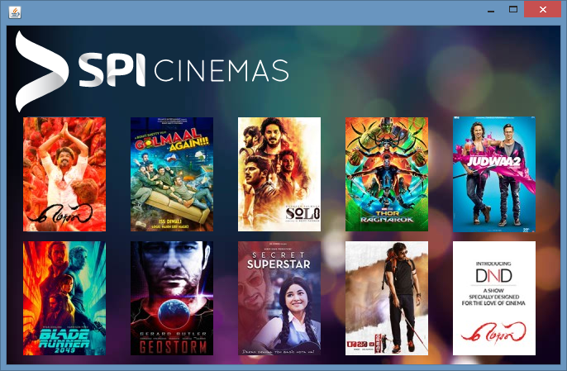

FRAME 5: Ticket Dates

public static int a;

private void cb1ActionPerformed(java.awt.event.ActionEvent evt) {

a = cb1.getSelectedIndex();

}

private void jButton1ActionPerformed(java.awt.event.ActionEvent evt) {

Show_Time o = new Show_Time();

o.setVisible(true);

this.dispose();

}

private void jButton2ActionPerformed(java.awt.event.ActionEvent evt) {

Show_Time o = new Show_Time();

o.setVisible(true);

this.dispose();

}

private void jButton3ActionPerformed(java.awt.event.ActionEvent evt) {

Show_Time o = new Show_Time();

o.setVisible(true);

this.dispose();

}

private void jButton4ActionPerformed(java.awt.event.ActionEvent evt) {

Show_Time o = new Show_Time();

o.setVisible(true);

this.dispose();

}

private void jButton5ActionPerformed(java.awt.event.ActionEvent evt) {

Show_Time o = new Show_Time();

o.setVisible(true);

this.dispose();

}

private void jButton6ActionPerformed(java.awt.event.ActionEvent evt) {

Show_Time o = new Show_Time();

o.setVisible(true);

this.dispose();

}

private void jButton7ActionPerformed(java.awt.event.ActionEvent evt) {

Show_Time o = new Show_Time();

o.setVisible(true);

this.dispose();

}

private void jButton8ActionPerformed(java.awt.event.ActionEvent evt) {

Show_Time o = new Show_Time();

o.setVisible(true);

this.dispose();

}

private void jButton9ActionPerformed(java.awt.event.ActionEvent evt) {

Show_Time o = new Show_Time();

o.setVisible(true);

this.dispose();

}

private void jButton10ActionPerformed(java.awt.event.ActionEvent evt) {

Show_Time o = new Show_Time();

o.setVisible(true);

this.dispose();

}

private void jButton11ActionPerformed(java.awt.event.ActionEvent evt) {

Show_Time o = new Show_Time();

o.setVisible(true);

this.dispose();

}

private void jButton12ActionPerformed(java.awt.event.ActionEvent evt) {

Show_Time o = new Show_Time();

o.setVisible(true);

this.dispose();

}

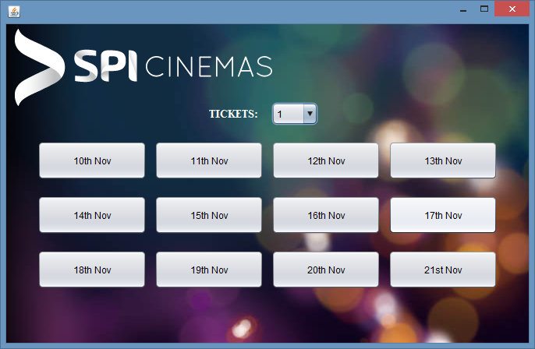

FRAME 6: Show Timings

private void jButton1ActionPerformed(java.awt.event.ActionEvent evt) {

Seat_Select_1 o = new Seat_Select_1();

o.setVisible(true);

this.dispose();

}

private void jButton2ActionPerformed(java.awt.event.ActionEvent evt) {

Seat_Select_3 o = new Seat_Select_3();

o.setVisible(true);

this.dispose();

}

private void jButton3ActionPerformed(java.awt.event.ActionEvent evt) {

Seat_Select_2 o = new Seat_Select_2();

o.setVisible(true);

this.dispose();

}

private void jButton4ActionPerformed(java.awt.event.ActionEvent evt) {

Seat_Select_1 o = new Seat_Select_1();

o.setVisible(true);

this.dispose();

}

private void jButton5ActionPerformed(java.awt.event.ActionEvent evt) {

Seat_Select_2 o = new Seat_Select_2();

o.setVisible(true);

this.dispose();

}

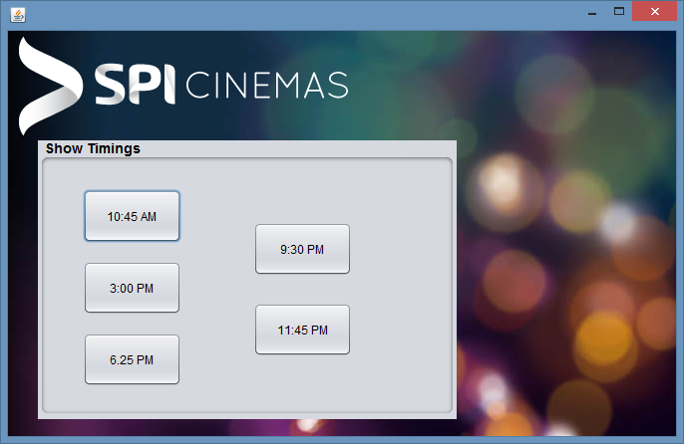

FRAME 7: Seat Selection 1

public static int b= Tickets_Dates.a+1;

public static int c=1;

private void b1ActionPerformed(java.awt.event.ActionEvent evt) {   
  
 if(c<b)

{b1.setIcon(new ImageIcon("C:\\Users\\KarthiK\\Downloads\\Year End Project\\Marked Seat.jpg"));

c++;}

else if(b==c)

{b1.setIcon(new ImageIcon("C:\\Users\\KarthiK\\Downloads\\Year End Project\\Marked Seat.jpg"));

Choose_Card o = new Choose_Card();

o.setVisible(true);

this.dispose();

}

}

private void b2ActionPerformed(java.awt.event.ActionEvent evt) {   
  
 if(c<b)

{b2.setIcon(new ImageIcon("C:\\Users\\KarthiK\\Downloads\\Year End Project\\Marked Seat.jpg"));

c++;}

else if(b==c)

{b2.setIcon(new ImageIcon("C:\\Users\\KarthiK\\Downloads\\Year End Project\\Marked Seat.jpg"));

Choose_Card o = new Choose_Card();

o.setVisible(true);

this.dispose();

}

}

private void b3ActionPerformed(java.awt.event.ActionEvent evt) {   
  
 if(c<b)

{b3.setIcon(new ImageIcon("C:\\Users\\KarthiK\\Downloads\\Year End Project\\Marked Seat.jpg"));

c++;}

else if(b==c)

{b3.setIcon(new ImageIcon("C:\\Users\\KarthiK\\Downloads\\Year End Project\\Marked Seat.jpg"));

Choose_Card o = new Choose_Card();

o.setVisible(true);

this.dispose();

}

}

private void b4ActionPerformed(java.awt.event.ActionEvent evt) {   
  
 if(c<b)

{b4.setIcon(new ImageIcon("C:\\Users\\KarthiK\\Downloads\\Year End Project\\Marked Seat.jpg"));

c++;}

else if(b==c)

{b4.setIcon(new ImageIcon("C:\\Users\\KarthiK\\Downloads\\Year End Project\\Marked Seat.jpg"));

Choose_Card o = new Choose_Card();

o.setVisible(true);

this.dispose();

}

}

private void b5ActionPerformed(java.awt.event.ActionEvent evt) {   
  
 if(c<b)

{b5.setIcon(new ImageIcon("C:\\Users\\KarthiK\\Downloads\\Year End Project\\Marked Seat.jpg"));

c++;}

else if(b==c)

{b5.setIcon(new ImageIcon("C:\\Users\\KarthiK\\Downloads\\Year End Project\\Marked Seat.jpg"));

Choose_Card o = new Choose_Card();

o.setVisible(true);

this.dispose();

}

}

private void b6ActionPerformed(java.awt.event.ActionEvent evt) {   
  
 if(c<b)

{b6.setIcon(new ImageIcon("C:\\Users\\KarthiK\\Downloads\\Year End Project\\Marked Seat.jpg"));

c++;}

else if(b==c)

{b6.setIcon(new ImageIcon("C:\\Users\\KarthiK\\Downloads\\Year End Project\\Marked Seat.jpg"));

Choose_Card o = new Choose_Card();

o.setVisible(true);

this.dispose();

}

}

private void b7ActionPerformed(java.awt.event.ActionEvent evt) {   
  
 if(c<b)

{b7.setIcon(new ImageIcon("C:\\Users\\KarthiK\\Downloads\\Year End Project\\Marked Seat.jpg"));

c++;}

else if(b==c)

{b7.setIcon(new ImageIcon("C:\\Users\\KarthiK\\Downloads\\Year End Project\\Marked Seat.jpg"));

Choose_Card o = new Choose_Card();

o.setVisible(true);

this.dispose();

}

}

private void b8ActionPerformed(java.awt.event.ActionEvent evt) {   
  
 if(c<b)

{b8.setIcon(new ImageIcon("C:\\Users\\KarthiK\\Downloads\\Year End Project\\Marked Seat.jpg"));

c++;}

else if(b==c)

{b8.setIcon(new ImageIcon("C:\\Users\\KarthiK\\Downloads\\Year End Project\\Marked Seat.jpg"));

Choose_Card o = new Choose_Card();

o.setVisible(true);

this.dispose();

}

}

private void b9ActionPerformed(java.awt.event.ActionEvent evt) {   
  
 if(c<b)

{b9.setIcon(new ImageIcon("C:\\Users\\KarthiK\\Downloads\\Year End Project\\Marked Seat.jpg"));

c++;}

else if(b==c)

{b9.setIcon(new ImageIcon("C:\\Users\\KarthiK\\Downloads\\Year End Project\\Marked Seat.jpg"));

Choose_Card o = new Choose_Card();

o.setVisible(true);

this.dispose();

}

}

private void b10ActionPerformed(java.awt.event.ActionEvent evt) {   
  
 if(c<b)

{b10.setIcon(new ImageIcon("C:\\Users\\KarthiK\\Downloads\\Year End Project\\Marked Seat.jpg"));

c++;}

else if(b==c)

{b10.setIcon(new ImageIcon("C:\\Users\\KarthiK\\Downloads\\Year End Project\\Marked Seat.jpg"));

Choose_Card o = new Choose_Card();

o.setVisible(true);

this.dispose();

}

}

private void b11ActionPerformed(java.awt.event.ActionEvent evt) {   
  
 if(c<b)

{b11.setIcon(new ImageIcon("C:\\Users\\KarthiK\\Downloads\\Year End Project\\Marked Seat.jpg"));

c++;}

else if(b==c)

{b11.setIcon(new ImageIcon("C:\\Users\\KarthiK\\Downloads\\Year End Project\\Marked Seat.jpg"));

Choose_Card o = new Choose_Card();

o.setVisible(true);

this.dispose();

}

}

private void b12ActionPerformed(java.awt.event.ActionEvent evt) {   
  
 if(c<b)

{b12.setIcon(new ImageIcon("C:\\Users\\KarthiK\\Downloads\\Year End Project\\Marked Seat.jpg"));

c++;}

else if(b==c)

{b12.setIcon(new ImageIcon("C:\\Users\\KarthiK\\Downloads\\Year End Project\\Marked Seat.jpg"));

Choose_Card o = new Choose_Card();

o.setVisible(true);

this.dispose();

}

}

private void b13ActionPerformed(java.awt.event.ActionEvent evt) {   
  
 if(c<b)

{b13.setIcon(new ImageIcon("C:\\Users\\KarthiK\\Downloads\\Year End Project\\Marked Seat.jpg"));

c++;}

else if(b==c)

{b13.setIcon(new ImageIcon("C:\\Users\\KarthiK\\Downloads\\Year End Project\\Marked Seat.jpg"));

Choose_Card o = new Choose_Card();

o.setVisible(true);

this.dispose();

}

}

private void b14ActionPerformed(java.awt.event.ActionEvent evt) {   
  
 if(c<b)

{b14.setIcon(new ImageIcon("C:\\Users\\KarthiK\\Downloads\\Year End Project\\Marked Seat.jpg"));

c++;}

else if(b==c)

{b14.setIcon(new ImageIcon("C:\\Users\\KarthiK\\Downloads\\Year End Project\\Marked Seat.jpg"));

Choose_Card o = new Choose_Card();

o.setVisible(true);

this.dispose();

}

}

private void b15ActionPerformed(java.awt.event.ActionEvent evt) {   
  
 if(c<b)

{b15.setIcon(new ImageIcon("C:\\Users\\KarthiK\\Downloads\\Year End Project\\Marked Seat.jpg"));

c++;}

else if(b==c)

{b15.setIcon(new ImageIcon("C:\\Users\\KarthiK\\Downloads\\Year End Project\\Marked Seat.jpg"));

Choose_Card o = new Choose_Card();

o.setVisible(true);

this.dispose();

}

}

private void b16ActionPerformed(java.awt.event.ActionEvent evt) {   
  
 if(c<b)

{b16.setIcon(new ImageIcon("C:\\Users\\KarthiK\\Downloads\\Year End Project\\Marked Seat.jpg"));

c++;}

else if(b==c)

{b16.setIcon(new ImageIcon("C:\\Users\\KarthiK\\Downloads\\Year End Project\\Marked Seat.jpg"));

Choose_Card o = new Choose_Card();

o.setVisible(true);

this.dispose();

}

}

private void b17ActionPerformed(java.awt.event.ActionEvent evt) {   
  
 if(c<b)

{b17.setIcon(new ImageIcon("C:\\Users\\KarthiK\\Downloads\\Year End Project\\Marked Seat.jpg"));

c++;}

else if(b==c)

{b17.setIcon(new ImageIcon("C:\\Users\\KarthiK\\Downloads\\Year End Project\\Marked Seat.jpg"));

Choose_Card o = new Choose_Card();

o.setVisible(true);

this.dispose();

}

}

private void b18ActionPerformed(java.awt.event.ActionEvent evt) {   
  
 if(c<b)

{b18.setIcon(new ImageIcon("C:\\Users\\KarthiK\\Downloads\\Year End Project\\Marked Seat.jpg"));

c++;}

else if(b==c)

{b18.setIcon(new ImageIcon("C:\\Users\\KarthiK\\Downloads\\Year End Project\\Marked Seat.jpg"));

Choose_Card o = new Choose_Card();

o.setVisible(true);

this.dispose();

}

}

private void b19ActionPerformed(java.awt.event.ActionEvent evt) {   
  
 if(c<b)

{b19.setIcon(new ImageIcon("C:\\Users\\KarthiK\\Downloads\\Year End Project\\Marked Seat.jpg"));

c++;}

else if(b==c)

{b19.setIcon(new ImageIcon("C:\\Users\\KarthiK\\Downloads\\Year End Project\\Marked Seat.jpg"));

Choose_Card o = new Choose_Card();

o.setVisible(true);

this.dispose();

}

}

private void b20ActionPerformed(java.awt.event.ActionEvent evt) {   
  
 if(c<b)

{b20.setIcon(new ImageIcon("C:\\Users\\KarthiK\\Downloads\\Year End Project\\Marked Seat.jpg"));

c++;}

else if(b==c)

{b20.setIcon(new ImageIcon("C:\\Users\\KarthiK\\Downloads\\Year End Project\\Marked Seat.jpg"));

Choose_Card o = new Choose_Card();

o.setVisible(true);

this.dispose();

}

}

private void b21ActionPerformed(java.awt.event.ActionEvent evt) {   
  
 if(c<b)

{b21.setIcon(new ImageIcon("C:\\Users\\KarthiK\\Downloads\\Year End Project\\Marked Seat.jpg"));

c++;}

else if(b==c)

{b21.setIcon(new ImageIcon("C:\\Users\\KarthiK\\Downloads\\Year End Project\\Marked Seat.jpg"));

Choose_Card o = new Choose_Card();

o.setVisible(true);

this.dispose();

}

}

private void b22ActionPerformed(java.awt.event.ActionEvent evt) {   
  
 if(c<b)

{b22.setIcon(new ImageIcon("C:\\Users\\KarthiK\\Downloads\\Year End Project\\Marked Seat.jpg"));

c++;}

else if(b==c)

{b22.setIcon(new ImageIcon("C:\\Users\\KarthiK\\Downloads\\Year End Project\\Marked Seat.jpg"));

Choose_Card o = new Choose_Card();

o.setVisible(true);

this.dispose();

}

}

private void b23ActionPerformed(java.awt.event.ActionEvent evt) {   
  
 if(c<b)

{b23.setIcon(new ImageIcon("C:\\Users\\KarthiK\\Downloads\\Year End Project\\Marked Seat.jpg"));

c++;}

else if(b==c)

{b23.setIcon(new ImageIcon("C:\\Users\\KarthiK\\Downloads\\Year End Project\\Marked Seat.jpg"));

Choose_Card o = new Choose_Card();

o.setVisible(true);

this.dispose();

}

}

private void b24ActionPerformed(java.awt.event.ActionEvent evt) {   
  
 if(c<b)

{b24.setIcon(new ImageIcon("C:\\Users\\KarthiK\\Downloads\\Year End Project\\Marked Seat.jpg"));

c++;}

else if(b==c)

{b24.setIcon(new ImageIcon("C:\\Users\\KarthiK\\Downloads\\Year End Project\\Marked Seat.jpg"));

Choose_Card o = new Choose_Card();

o.setVisible(true);

this.dispose();

}

}

private void b25ActionPerformed(java.awt.event.ActionEvent evt) {   
  
 if(c<b)

{b25.setIcon(new ImageIcon("C:\\Users\\KarthiK\\Downloads\\Year End Project\\Marked Seat.jpg"));

c++;}

else if(b==c)

{b25.setIcon(new ImageIcon("C:\\Users\\KarthiK\\Downloads\\Year End Project\\Marked Seat.jpg"));

Choose_Card o = new Choose_Card();

o.setVisible(true);

this.dispose();

}

}

private void b26ActionPerformed(java.awt.event.ActionEvent evt) {   
  
 if(c<b)

{b26.setIcon(new ImageIcon("C:\\Users\\KarthiK\\Downloads\\Year End Project\\Marked Seat.jpg"));

c++;}

else if(b==c)

{b26.setIcon(new ImageIcon("C:\\Users\\KarthiK\\Downloads\\Year End Project\\Marked Seat.jpg"));

Choose_Card o = new Choose_Card();

o.setVisible(true);

this.dispose();

}

}

private void b27ActionPerformed(java.awt.event.ActionEvent evt) {   
  
 if(c<b)

{b27.setIcon(new ImageIcon("C:\\Users\\KarthiK\\Downloads\\Year End Project\\Marked Seat.jpg"));

c++;}

else if(b==c)

{b27.setIcon(new ImageIcon("C:\\Users\\KarthiK\\Downloads\\Year End Project\\Marked Seat.jpg"));

Choose_Card o = new Choose_Card();

o.setVisible(true);

this.dispose();

}

}

private void b28ActionPerformed(java.awt.event.ActionEvent evt) {   
  
 if(c<b)

{b28.setIcon(new ImageIcon("C:\\Users\\KarthiK\\Downloads\\Year End Project\\Marked Seat.jpg"));

c++;}

else if(b==c)

{b28.setIcon(new ImageIcon("C:\\Users\\KarthiK\\Downloads\\Year End Project\\Marked Seat.jpg"));

Choose_Card o = new Choose_Card();

o.setVisible(true);

this.dispose();

}

}

private void b29ActionPerformed(java.awt.event.ActionEvent evt) {   
  
 if(c<b)

{b29.setIcon(new ImageIcon("C:\\Users\\KarthiK\\Downloads\\Year End Project\\Marked Seat.jpg"));

c++;}

else if(b==c)

{b29.setIcon(new ImageIcon("C:\\Users\\KarthiK\\Downloads\\Year End Project\\Marked Seat.jpg"));

Choose_Card o = new Choose_Card();

o.setVisible(true);

this.dispose();

}

}

private void b30ActionPerformed(java.awt.event.ActionEvent evt) {   
  
 if(c<b)

{b30.setIcon(new ImageIcon("C:\\Users\\KarthiK\\Downloads\\Year End Project\\Marked Seat.jpg"));

c++;}

else if(b==c)

{b30.setIcon(new ImageIcon("C:\\Users\\KarthiK\\Downloads\\Year End Project\\Marked Seat.jpg"));

Choose_Card o = new Choose_Card();

o.setVisible(true);

this.dispose();

}

}

private void b31ActionPerformed(java.awt.event.ActionEvent evt) {   
  
 if(c<b)

{312.setIcon(new ImageIcon("C:\\Users\\KarthiK\\Downloads\\Year End Project\\Marked Seat.jpg"));

c++;}

else if(b==c)

{b31.setIcon(new ImageIcon("C:\\Users\\KarthiK\\Downloads\\Year End Project\\Marked Seat.jpg"));

Choose_Card o = new Choose_Card();

o.setVisible(true);

this.dispose();

}

}

private void b32ActionPerformed(java.awt.event.ActionEvent evt) {   
  
 if(c<b)

{b32.setIcon(new ImageIcon("C:\\Users\\KarthiK\\Downloads\\Year End Project\\Marked Seat.jpg"));

c++;}

else if(b==c)

{b32.setIcon(new ImageIcon("C:\\Users\\KarthiK\\Downloads\\Year End Project\\Marked Seat.jpg"));

Choose_Card o = new Choose_Card();

o.setVisible(true);

this.dispose();

}

}

private void b33ActionPerformed(java.awt.event.ActionEvent evt) {   
  
 if(c<b)

{b33.setIcon(new ImageIcon("C:\\Users\\KarthiK\\Downloads\\Year End Project\\Marked Seat.jpg"));

c++;}

else if(b==c)

{b33.setIcon(new ImageIcon("C:\\Users\\KarthiK\\Downloads\\Year End Project\\Marked Seat.jpg"));

Choose_Card o = new Choose_Card();

o.setVisible(true);

this.dispose();

}

}

private void b34ActionPerformed(java.awt.event.ActionEvent evt) {   
  
 if(c<b)

{b34.setIcon(new ImageIcon("C:\\Users\\KarthiK\\Downloads\\Year End Project\\Marked Seat.jpg"));

c++;}

else if(b==c)

{b34.setIcon(new ImageIcon("C:\\Users\\KarthiK\\Downloads\\Year End Project\\Marked Seat.jpg"));

Choose_Card o = new Choose_Card();

o.setVisible(true);

this.dispose();

}

}

private void b35ActionPerformed(java.awt.event.ActionEvent evt) {   
  
 if(c<b)

{b35.setIcon(new ImageIcon("C:\\Users\\KarthiK\\Downloads\\Year End Project\\Marked Seat.jpg"));

c++;}

else if(b==c)

{b35.setIcon(new ImageIcon("C:\\Users\\KarthiK\\Downloads\\Year End Project\\Marked Seat.jpg"));

Choose_Card o = new Choose_Card();

o.setVisible(true);

this.dispose();

}

}

private void b36ActionPerformed(java.awt.event.ActionEvent evt) {   
  
 if(c<b)

{b36.setIcon(new ImageIcon("C:\\Users\\KarthiK\\Downloads\\Year End Project\\Marked Seat.jpg"));

c++;}

else if(b==c)

{b36.setIcon(new ImageIcon("C:\\Users\\KarthiK\\Downloads\\Year End Project\\Marked Seat.jpg"));

Choose_Card o = new Choose_Card();

o.setVisible(true);

this.dispose();

}

}

private void b37ActionPerformed(java.awt.event.ActionEvent evt) {   
  
 if(c<b)

{b37.setIcon(new ImageIcon("C:\\Users\\KarthiK\\Downloads\\Year End Project\\Marked Seat.jpg"));

c++;}

else if(b==c)

{b37.setIcon(new ImageIcon("C:\\Users\\KarthiK\\Downloads\\Year End Project\\Marked Seat.jpg"));

Choose_Card o = new Choose_Card();

o.setVisible(true);

this.dispose();

}

}

private void b38ActionPerformed(java.awt.event.ActionEvent evt) {   
  
 if(c<b)

{b38.setIcon(new ImageIcon("C:\\Users\\KarthiK\\Downloads\\Year End Project\\Marked Seat.jpg"));

c++;}

else if(b==c)

{b38.setIcon(new ImageIcon("C:\\Users\\KarthiK\\Downloads\\Year End Project\\Marked Seat.jpg"));

Choose_Card o = new Choose_Card();

o.setVisible(true);

this.dispose();

}

}

private void b39ActionPerformed(java.awt.event.ActionEvent evt) {   
  
 if(c<b)

{b39.setIcon(new ImageIcon("C:\\Users\\KarthiK\\Downloads\\Year End Project\\Marked Seat.jpg"));

c++;}

else if(b==c)

{b39.setIcon(new ImageIcon("C:\\Users\\KarthiK\\Downloads\\Year End Project\\Marked Seat.jpg"));

Choose_Card o = new Choose_Card();

o.setVisible(true);

this.dispose();

}

}

private void b40ActionPerformed(java.awt.event.ActionEvent evt) {   
  
 if(c<b)

{b40.setIcon(new ImageIcon("C:\\Users\\KarthiK\\Downloads\\Year End Project\\Marked Seat.jpg"));

c++;}

else if(b==c)

{b40.setIcon(new ImageIcon("C:\\Users\\KarthiK\\Downloads\\Year End Project\\Marked Seat.jpg"));

Choose_Card o = new Choose_Card();

o.setVisible(true);

this.dispose();

}

}

private void b41ActionPerformed(java.awt.event.ActionEvent evt) {   
  
 if(c<b)

{b41.setIcon(new ImageIcon("C:\\Users\\KarthiK\\Downloads\\Year End Project\\Marked Seat.jpg"));

c++;}

else if(b==c)

{b41.setIcon(new ImageIcon("C:\\Users\\KarthiK\\Downloads\\Year End Project\\Marked Seat.jpg"));

Choose_Card o = new Choose_Card();

o.setVisible(true);

this.dispose();

}

}

private void b42ActionPerformed(java.awt.event.ActionEvent evt) {   
  
 if(c<b)

{b42.setIcon(new ImageIcon("C:\\Users\\KarthiK\\Downloads\\Year End Project\\Marked Seat.jpg"));

c++;}

else if(b==c)

{b42.setIcon(new ImageIcon("C:\\Users\\KarthiK\\Downloads\\Year End Project\\Marked Seat.jpg"));

Choose_Card o = new Choose_Card();

o.setVisible(true);

this.dispose();

}

}

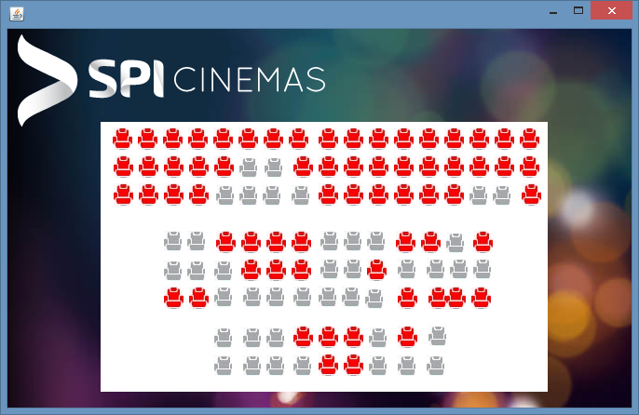

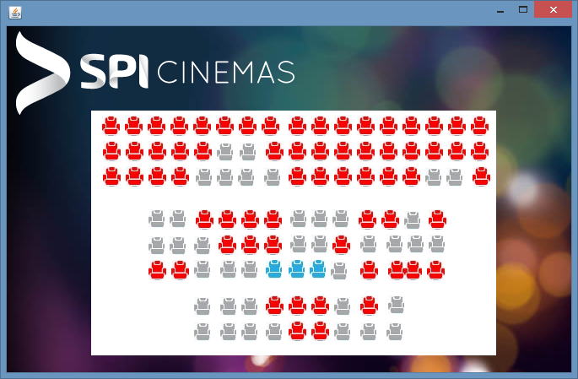

FRAME 8: Seat Selection 2

public static int b= Tickets_Dates.a+1;

public static int c=1;

private void b1ActionPerformed(java.awt.event.ActionEvent evt) {   
  
 if(c<b)

{b1.setIcon(new ImageIcon("C:\\Users\\KarthiK\\Downloads\\Year End Project\\Marked Seat.jpg"));

c++;}

else if(b==c)

{b1.setIcon(new ImageIcon("C:\\Users\\KarthiK\\Downloads\\Year End Project\\Marked Seat.jpg"));

Choose_Card o = new Choose_Card();

o.setVisible(true);

this.dispose();

}

}

private void b2ActionPerformed(java.awt.event.ActionEvent evt) {   
  
 if(c<b)

{b2.setIcon(new ImageIcon("C:\\Users\\KarthiK\\Downloads\\Year End Project\\Marked Seat.jpg"));

c++;}

else if(b==c)

{b2.setIcon(new ImageIcon("C:\\Users\\KarthiK\\Downloads\\Year End Project\\Marked Seat.jpg"));

Choose_Card o = new Choose_Card();

o.setVisible(true);

this.dispose();

}

}

private void b3ActionPerformed(java.awt.event.ActionEvent evt) {   
  
 if(c<b)

{b3.setIcon(new ImageIcon("C:\\Users\\KarthiK\\Downloads\\Year End Project\\Marked Seat.jpg"));

c++;}

else if(b==c)

{b3.setIcon(new ImageIcon("C:\\Users\\KarthiK\\Downloads\\Year End Project\\Marked Seat.jpg"));

Choose_Card o = new Choose_Card();

o.setVisible(true);

this.dispose();

}

}

private void b4ActionPerformed(java.awt.event.ActionEvent evt) {   
  
 if(c<b)

{b4.setIcon(new ImageIcon("C:\\Users\\KarthiK\\Downloads\\Year End Project\\Marked Seat.jpg"));

c++;}

else if(b==c)

{b4.setIcon(new ImageIcon("C:\\Users\\KarthiK\\Downloads\\Year End Project\\Marked Seat.jpg"));

Choose_Card o = new Choose_Card();

o.setVisible(true);

this.dispose();

}

}

private void b5ActionPerformed(java.awt.event.ActionEvent evt) {   
  
 if(c<b)

{b5.setIcon(new ImageIcon("C:\\Users\\KarthiK\\Downloads\\Year End Project\\Marked Seat.jpg"));

c++;}

else if(b==c)

{b5.setIcon(new ImageIcon("C:\\Users\\KarthiK\\Downloads\\Year End Project\\Marked Seat.jpg"));

Choose_Card o = new Choose_Card();

o.setVisible(true);

this.dispose();

}

}

private void b6ActionPerformed(java.awt.event.ActionEvent evt) {   
  
 if(c<b)

{b6.setIcon(new ImageIcon("C:\\Users\\KarthiK\\Downloads\\Year End Project\\Marked Seat.jpg"));

c++;}

else if(b==c)

{b6.setIcon(new ImageIcon("C:\\Users\\KarthiK\\Downloads\\Year End Project\\Marked Seat.jpg"));

Choose_Card o = new Choose_Card();

o.setVisible(true);

this.dispose();

}

}

private void b7ActionPerformed(java.awt.event.ActionEvent evt) {   
  
 if(c<b)

{b7.setIcon(new ImageIcon("C:\\Users\\KarthiK\\Downloads\\Year End Project\\Marked Seat.jpg"));

c++;}

else if(b==c)

{b7.setIcon(new ImageIcon("C:\\Users\\KarthiK\\Downloads\\Year End Project\\Marked Seat.jpg"));

Choose_Card o = new Choose_Card();

o.setVisible(true);

this.dispose();

}

}

private void b8ActionPerformed(java.awt.event.ActionEvent evt) {   
  
 if(c<b)

{b8.setIcon(new ImageIcon("C:\\Users\\KarthiK\\Downloads\\Year End Project\\Marked Seat.jpg"));

c++;}

else if(b==c)

{b8.setIcon(new ImageIcon("C:\\Users\\KarthiK\\Downloads\\Year End Project\\Marked Seat.jpg"));

Choose_Card o = new Choose_Card();

o.setVisible(true);

this.dispose();

}

}

private void b9ActionPerformed(java.awt.event.ActionEvent evt) {   
  
 if(c<b)

{b9.setIcon(new ImageIcon("C:\\Users\\KarthiK\\Downloads\\Year End Project\\Marked Seat.jpg"));

c++;}

else if(b==c)

{b9.setIcon(new ImageIcon("C:\\Users\\KarthiK\\Downloads\\Year End Project\\Marked Seat.jpg"));

Choose_Card o = new Choose_Card();

o.setVisible(true);

this.dispose();

}

}

private void b10ActionPerformed(java.awt.event.ActionEvent evt) {   
  
 if(c<b)

{b10.setIcon(new ImageIcon("C:\\Users\\KarthiK\\Downloads\\Year End Project\\Marked Seat.jpg"));

c++;}

else if(b==c)

{b10.setIcon(new ImageIcon("C:\\Users\\KarthiK\\Downloads\\Year End Project\\Marked Seat.jpg"));

Choose_Card o = new Choose_Card();

o.setVisible(true);

this.dispose();

}

}

private void b11ActionPerformed(java.awt.event.ActionEvent evt) {   
  
 if(c<b)

{b11.setIcon(new ImageIcon("C:\\Users\\KarthiK\\Downloads\\Year End Project\\Marked Seat.jpg"));

c++;}

else if(b==c)

{b11.setIcon(new ImageIcon("C:\\Users\\KarthiK\\Downloads\\Year End Project\\Marked Seat.jpg"));

Choose_Card o = new Choose_Card();

o.setVisible(true);

this.dispose();

}

}

private void b12ActionPerformed(java.awt.event.ActionEvent evt) {   
  
 if(c<b)

{b12.setIcon(new ImageIcon("C:\\Users\\KarthiK\\Downloads\\Year End Project\\Marked Seat.jpg"));

c++;}

else if(b==c)

{b12.setIcon(new ImageIcon("C:\\Users\\KarthiK\\Downloads\\Year End Project\\Marked Seat.jpg"));

Choose_Card o = new Choose_Card();

o.setVisible(true);

this.dispose();

}

}

private void b13ActionPerformed(java.awt.event.ActionEvent evt) {   
  
 if(c<b)

{b13.setIcon(new ImageIcon("C:\\Users\\KarthiK\\Downloads\\Year End Project\\Marked Seat.jpg"));

c++;}

else if(b==c)

{b13.setIcon(new ImageIcon("C:\\Users\\KarthiK\\Downloads\\Year End Project\\Marked Seat.jpg"));

Choose_Card o = new Choose_Card();

o.setVisible(true);

this.dispose();

}

}

private void b14ActionPerformed(java.awt.event.ActionEvent evt) {   
  
 if(c<b)

{b14.setIcon(new ImageIcon("C:\\Users\\KarthiK\\Downloads\\Year End Project\\Marked Seat.jpg"));

c++;}

else if(b==c)

{b14.setIcon(new ImageIcon("C:\\Users\\KarthiK\\Downloads\\Year End Project\\Marked Seat.jpg"));

Choose_Card o = new Choose_Card();

o.setVisible(true);

this.dispose();

}

}

private void b15ActionPerformed(java.awt.event.ActionEvent evt) {   
  
 if(c<b)

{b15.setIcon(new ImageIcon("C:\\Users\\KarthiK\\Downloads\\Year End Project\\Marked Seat.jpg"));

c++;}

else if(b==c)

{b15.setIcon(new ImageIcon("C:\\Users\\KarthiK\\Downloads\\Year End Project\\Marked Seat.jpg"));

Choose_Card o = new Choose_Card();

o.setVisible(true);

this.dispose();

}

}

private void b16ActionPerformed(java.awt.event.ActionEvent evt) {   
  
 if(c<b)

{b16.setIcon(new ImageIcon("C:\\Users\\KarthiK\\Downloads\\Year End Project\\Marked Seat.jpg"));

c++;}

else if(b==c)

{b16.setIcon(new ImageIcon("C:\\Users\\KarthiK\\Downloads\\Year End Project\\Marked Seat.jpg"));

Choose_Card o = new Choose_Card();

o.setVisible(true);

this.dispose();

}

}

private void b17ActionPerformed(java.awt.event.ActionEvent evt) {   
  
 if(c<b)

{b17.setIcon(new ImageIcon("C:\\Users\\KarthiK\\Downloads\\Year End Project\\Marked Seat.jpg"));

c++;}

else if(b==c)

{b17.setIcon(new ImageIcon("C:\\Users\\KarthiK\\Downloads\\Year End Project\\Marked Seat.jpg"));

Choose_Card o = new Choose_Card();

o.setVisible(true);

this.dispose();

}

}

private void b18ActionPerformed(java.awt.event.ActionEvent evt) {   
  
 if(c<b)

{b18.setIcon(new ImageIcon("C:\\Users\\KarthiK\\Downloads\\Year End Project\\Marked Seat.jpg"));

c++;}

else if(b==c)

{b18.setIcon(new ImageIcon("C:\\Users\\KarthiK\\Downloads\\Year End Project\\Marked Seat.jpg"));

Choose_Card o = new Choose_Card();

o.setVisible(true);

this.dispose();

}

}

private void b19ActionPerformed(java.awt.event.ActionEvent evt) {   
  
 if(c<b)

{b19.setIcon(new ImageIcon("C:\\Users\\KarthiK\\Downloads\\Year End Project\\Marked Seat.jpg"));

c++;}

else if(b==c)

{b19.setIcon(new ImageIcon("C:\\Users\\KarthiK\\Downloads\\Year End Project\\Marked Seat.jpg"));

Choose_Card o = new Choose_Card();

o.setVisible(true);

this.dispose();

}

}

private void b20ActionPerformed(java.awt.event.ActionEvent evt) {   
  
 if(c<b)

{b20.setIcon(new ImageIcon("C:\\Users\\KarthiK\\Downloads\\Year End Project\\Marked Seat.jpg"));

c++;}

else if(b==c)

{b20.setIcon(new ImageIcon("C:\\Users\\KarthiK\\Downloads\\Year End Project\\Marked Seat.jpg"));

Choose_Card o = new Choose_Card();

o.setVisible(true);

this.dispose();

}

}

private void b21ActionPerformed(java.awt.event.ActionEvent evt) {   
  
 if(c<b)

{b21.setIcon(new ImageIcon("C:\\Users\\KarthiK\\Downloads\\Year End Project\\Marked Seat.jpg"));

c++;}

else if(b==c)

{b21.setIcon(new ImageIcon("C:\\Users\\KarthiK\\Downloads\\Year End Project\\Marked Seat.jpg"));

Choose_Card o = new Choose_Card();

o.setVisible(true);

this.dispose();

}

}

private void b22ActionPerformed(java.awt.event.ActionEvent evt) {   
  
 if(c<b)

{b22.setIcon(new ImageIcon("C:\\Users\\KarthiK\\Downloads\\Year End Project\\Marked Seat.jpg"));

c++;}

else if(b==c)

{b22.setIcon(new ImageIcon("C:\\Users\\KarthiK\\Downloads\\Year End Project\\Marked Seat.jpg"));

Choose_Card o = new Choose_Card();

o.setVisible(true);

this.dispose();

}

}

private void b23ActionPerformed(java.awt.event.ActionEvent evt) {   
  
 if(c<b)

{b23.setIcon(new ImageIcon("C:\\Users\\KarthiK\\Downloads\\Year End Project\\Marked Seat.jpg"));

c++;}

else if(b==c)

{b23.setIcon(new ImageIcon("C:\\Users\\KarthiK\\Downloads\\Year End Project\\Marked Seat.jpg"));

Choose_Card o = new Choose_Card();

o.setVisible(true);

this.dispose();

}

}

private void b24ActionPerformed(java.awt.event.ActionEvent evt) {   
  
 if(c<b)

{b24.setIcon(new ImageIcon("C:\\Users\\KarthiK\\Downloads\\Year End Project\\Marked Seat.jpg"));

c++;}

else if(b==c)

{b24.setIcon(new ImageIcon("C:\\Users\\KarthiK\\Downloads\\Year End Project\\Marked Seat.jpg"));

Choose_Card o = new Choose_Card();

o.setVisible(true);

this.dispose();

}

}

private void b25ActionPerformed(java.awt.event.ActionEvent evt) {   
  
 if(c<b)

{b25.setIcon(new ImageIcon("C:\\Users\\KarthiK\\Downloads\\Year End Project\\Marked Seat.jpg"));

c++;}

else if(b==c)

{b25.setIcon(new ImageIcon("C:\\Users\\KarthiK\\Downloads\\Year End Project\\Marked Seat.jpg"));

Choose_Card o = new Choose_Card();

o.setVisible(true);

this.dispose();

}

}

private void b26ActionPerformed(java.awt.event.ActionEvent evt) {   
  
 if(c<b)

{b26.setIcon(new ImageIcon("C:\\Users\\KarthiK\\Downloads\\Year End Project\\Marked Seat.jpg"));

c++;}

else if(b==c)

{b26.setIcon(new ImageIcon("C:\\Users\\KarthiK\\Downloads\\Year End Project\\Marked Seat.jpg"));

Choose_Card o = new Choose_Card();

o.setVisible(true);

this.dispose();

}

}

private void b27ActionPerformed(java.awt.event.ActionEvent evt) {   
  
 if(c<b)

{b27.setIcon(new ImageIcon("C:\\Users\\KarthiK\\Downloads\\Year End Project\\Marked Seat.jpg"));

c++;}

else if(b==c)

{b27.setIcon(new ImageIcon("C:\\Users\\KarthiK\\Downloads\\Year End Project\\Marked Seat.jpg"));

Choose_Card o = new Choose_Card();

o.setVisible(true);

this.dispose();

}

}

private void b28ActionPerformed(java.awt.event.ActionEvent evt) {   
  
 if(c<b)

{b28.setIcon(new ImageIcon("C:\\Users\\KarthiK\\Downloads\\Year End Project\\Marked Seat.jpg"));

c++;}

else if(b==c)

{b28.setIcon(new ImageIcon("C:\\Users\\KarthiK\\Downloads\\Year End Project\\Marked Seat.jpg"));

Choose_Card o = new Choose_Card();

o.setVisible(true);

this.dispose();

}

}

private void b29ActionPerformed(java.awt.event.ActionEvent evt) {   
  
 if(c<b)

{b29.setIcon(new ImageIcon("C:\\Users\\KarthiK\\Downloads\\Year End Project\\Marked Seat.jpg"));

c++;}

else if(b==c)

{b29.setIcon(new ImageIcon("C:\\Users\\KarthiK\\Downloads\\Year End Project\\Marked Seat.jpg"));

Choose_Card o = new Choose_Card();

o.setVisible(true);

this.dispose();

}

}

private void b30ActionPerformed(java.awt.event.ActionEvent evt) {   
  
 if(c<b)

{b30.setIcon(new ImageIcon("C:\\Users\\KarthiK\\Downloads\\Year End Project\\Marked Seat.jpg"));

c++;}

else if(b==c)

{b30.setIcon(new ImageIcon("C:\\Users\\KarthiK\\Downloads\\Year End Project\\Marked Seat.jpg"));

Choose_Card o = new Choose_Card();

o.setVisible(true);

this.dispose();

}

}

private void b31ActionPerformed(java.awt.event.ActionEvent evt) {   
  
 if(c<b)

{312.setIcon(new ImageIcon("C:\\Users\\KarthiK\\Downloads\\Year End Project\\Marked Seat.jpg"));

c++;}

else if(b==c)

{b31.setIcon(new ImageIcon("C:\\Users\\KarthiK\\Downloads\\Year End Project\\Marked Seat.jpg"));

Choose_Card o = new Choose_Card();

o.setVisible(true);

this.dispose();

}

}

private void b32ActionPerformed(java.awt.event.ActionEvent evt) {   
  
 if(c<b)

{b32.setIcon(new ImageIcon("C:\\Users\\KarthiK\\Downloads\\Year End Project\\Marked Seat.jpg"));

c++;}

else if(b==c)

{b32.setIcon(new ImageIcon("C:\\Users\\KarthiK\\Downloads\\Year End Project\\Marked Seat.jpg"));

Choose_Card o = new Choose_Card();

o.setVisible(true);

this.dispose();

}

}

private void b33ActionPerformed(java.awt.event.ActionEvent evt) {   
  
 if(c<b)

{b33.setIcon(new ImageIcon("C:\\Users\\KarthiK\\Downloads\\Year End Project\\Marked Seat.jpg"));

c++;}

else if(b==c)

{b33.setIcon(new ImageIcon("C:\\Users\\KarthiK\\Downloads\\Year End Project\\Marked Seat.jpg"));

Choose_Card o = new Choose_Card();

o.setVisible(true);

this.dispose();

}

}

private void b34ActionPerformed(java.awt.event.ActionEvent evt) {   
  
 if(c<b)

{b34.setIcon(new ImageIcon("C:\\Users\\KarthiK\\Downloads\\Year End Project\\Marked Seat.jpg"));

c++;}

else if(b==c)

{b34.setIcon(new ImageIcon("C:\\Users\\KarthiK\\Downloads\\Year End Project\\Marked Seat.jpg"));

Choose_Card o = new Choose_Card();

o.setVisible(true);

this.dispose();

}

}

private void b35ActionPerformed(java.awt.event.ActionEvent evt) {   
  
 if(c<b)

{b35.setIcon(new ImageIcon("C:\\Users\\KarthiK\\Downloads\\Year End Project\\Marked Seat.jpg"));

c++;}

else if(b==c)

{b35.setIcon(new ImageIcon("C:\\Users\\KarthiK\\Downloads\\Year End Project\\Marked Seat.jpg"));

Choose_Card o = new Choose_Card();

o.setVisible(true);

this.dispose();

}

}

private void b36ActionPerformed(java.awt.event.ActionEvent evt) {   
  
 if(c<b)

{b36.setIcon(new ImageIcon("C:\\Users\\KarthiK\\Downloads\\Year End Project\\Marked Seat.jpg"));

c++;}

else if(b==c)

{b36.setIcon(new ImageIcon("C:\\Users\\KarthiK\\Downloads\\Year End Project\\Marked Seat.jpg"));

Choose_Card o = new Choose_Card();

o.setVisible(true);

this.dispose();

}

}

private void b37ActionPerformed(java.awt.event.ActionEvent evt) {   
  
 if(c<b)

{b37.setIcon(new ImageIcon("C:\\Users\\KarthiK\\Downloads\\Year End Project\\Marked Seat.jpg"));

c++;}

else if(b==c)

{b37.setIcon(new ImageIcon("C:\\Users\\KarthiK\\Downloads\\Year End Project\\Marked Seat.jpg"));

Choose_Card o = new Choose_Card();

o.setVisible(true);

this.dispose();

}

}

private void b38ActionPerformed(java.awt.event.ActionEvent evt) {   
  
 if(c<b)

{b38.setIcon(new ImageIcon("C:\\Users\\KarthiK\\Downloads\\Year End Project\\Marked Seat.jpg"));

c++;}

else if(b==c)

{b38.setIcon(new ImageIcon("C:\\Users\\KarthiK\\Downloads\\Year End Project\\Marked Seat.jpg"));

Choose_Card o = new Choose_Card();

o.setVisible(true);

this.dispose();

}

}

private void b39ActionPerformed(java.awt.event.ActionEvent evt) {   
  
 if(c<b)

{b39.setIcon(new ImageIcon("C:\\Users\\KarthiK\\Downloads\\Year End Project\\Marked Seat.jpg"));

c++;}

else if(b==c)

{b39.setIcon(new ImageIcon("C:\\Users\\KarthiK\\Downloads\\Year End Project\\Marked Seat.jpg"));

Choose_Card o = new Choose_Card();

o.setVisible(true);

this.dispose();

}

}

private void b40ActionPerformed(java.awt.event.ActionEvent evt) {   
  
 if(c<b)

{b40.setIcon(new ImageIcon("C:\\Users\\KarthiK\\Downloads\\Year End Project\\Marked Seat.jpg"));

c++;}

else if(b==c)

{b40.setIcon(new ImageIcon("C:\\Users\\KarthiK\\Downloads\\Year End Project\\Marked Seat.jpg"));

Choose_Card o = new Choose_Card();

o.setVisible(true);

this.dispose();

}

}

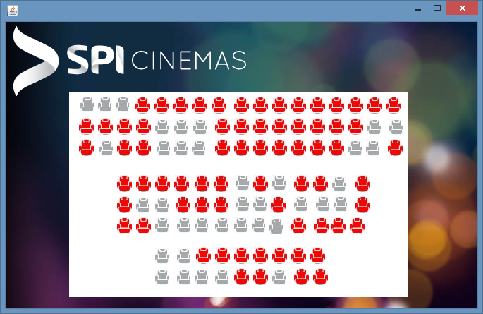

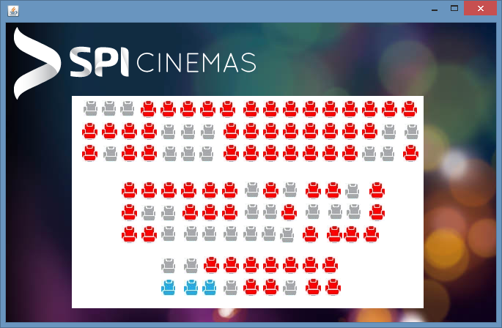

FRAME 9: Seat Selection 3

public static int b= Tickets_Dates.a+1;

public static int c=1;

private void b1ActionPerformed(java.awt.event.ActionEvent evt) {   
  
 if(c<b)

{b1.setIcon(new ImageIcon("C:\\Users\\KarthiK\\Downloads\\Year End Project\\Marked Seat.jpg"));

c++;}

else if(b==c)

{b1.setIcon(new ImageIcon("C:\\Users\\KarthiK\\Downloads\\Year End Project\\Marked Seat.jpg"));

Choose_Card o = new Choose_Card();

o.setVisible(true);

this.dispose();

}

}

private void b2ActionPerformed(java.awt.event.ActionEvent evt) {   
  
 if(c<b)

{b2.setIcon(new ImageIcon("C:\\Users\\KarthiK\\Downloads\\Year End Project\\Marked Seat.jpg"));

c++;}

else if(b==c)

{b2.setIcon(new ImageIcon("C:\\Users\\KarthiK\\Downloads\\Year End Project\\Marked Seat.jpg"));

Choose_Card o = new Choose_Card();

o.setVisible(true);

this.dispose();

}

}

private void b3ActionPerformed(java.awt.event.ActionEvent evt) {   
  
 if(c<b)

{b3.setIcon(new ImageIcon("C:\\Users\\KarthiK\\Downloads\\Year End Project\\Marked Seat.jpg"));

c++;}

else if(b==c)

{b3.setIcon(new ImageIcon("C:\\Users\\KarthiK\\Downloads\\Year End Project\\Marked Seat.jpg"));

Choose_Card o = new Choose_Card();

o.setVisible(true);

this.dispose();

}

}

private void b4ActionPerformed(java.awt.event.ActionEvent evt) {   
  
 if(c<b)

{b4.setIcon(new ImageIcon("C:\\Users\\KarthiK\\Downloads\\Year End Project\\Marked Seat.jpg"));

c++;}

else if(b==c)

{b4.setIcon(new ImageIcon("C:\\Users\\KarthiK\\Downloads\\Year End Project\\Marked Seat.jpg"));

Choose_Card o = new Choose_Card();

o.setVisible(true);

this.dispose();

}

}

private void b5ActionPerformed(java.awt.event.ActionEvent evt) {   
  
 if(c<b)

{b5.setIcon(new ImageIcon("C:\\Users\\KarthiK\\Downloads\\Year End Project\\Marked Seat.jpg"));

c++;}

else if(b==c)

{b5.setIcon(new ImageIcon("C:\\Users\\KarthiK\\Downloads\\Year End Project\\Marked Seat.jpg"));

Choose_Card o = new Choose_Card();

o.setVisible(true);

this.dispose();

}

}

private void b6ActionPerformed(java.awt.event.ActionEvent evt) {   
  
 if(c<b)

{b6.setIcon(new ImageIcon("C:\\Users\\KarthiK\\Downloads\\Year End Project\\Marked Seat.jpg"));

c++;}

else if(b==c)

{b6.setIcon(new ImageIcon("C:\\Users\\KarthiK\\Downloads\\Year End Project\\Marked Seat.jpg"));

Choose_Card o = new Choose_Card();

o.setVisible(true);

this.dispose();

}

}

private void b7ActionPerformed(java.awt.event.ActionEvent evt) {   
  
 if(c<b)

{b7.setIcon(new ImageIcon("C:\\Users\\KarthiK\\Downloads\\Year End Project\\Marked Seat.jpg"));

c++;}

else if(b==c)

{b7.setIcon(new ImageIcon("C:\\Users\\KarthiK\\Downloads\\Year End Project\\Marked Seat.jpg"));

Choose_Card o = new Choose_Card();

o.setVisible(true);

this.dispose();

}

}

private void b8ActionPerformed(java.awt.event.ActionEvent evt) {   
  
 if(c<b)

{b8.setIcon(new ImageIcon("C:\\Users\\KarthiK\\Downloads\\Year End Project\\Marked Seat.jpg"));

c++;}

else if(b==c)

{b8.setIcon(new ImageIcon("C:\\Users\\KarthiK\\Downloads\\Year End Project\\Marked Seat.jpg"));

Choose_Card o = new Choose_Card();

o.setVisible(true);

this.dispose();

}

}

private void b9ActionPerformed(java.awt.event.ActionEvent evt) {   
  
 if(c<b)

{b9.setIcon(new ImageIcon("C:\\Users\\KarthiK\\Downloads\\Year End Project\\Marked Seat.jpg"));

c++;}

else if(b==c)

{b9.setIcon(new ImageIcon("C:\\Users\\KarthiK\\Downloads\\Year End Project\\Marked Seat.jpg"));

Choose_Card o = new Choose_Card();

o.setVisible(true);

this.dispose();

}

}

private void b10ActionPerformed(java.awt.event.ActionEvent evt) {   
  
 if(c<b)

{b10.setIcon(new ImageIcon("C:\\Users\\KarthiK\\Downloads\\Year End Project\\Marked Seat.jpg"));

c++;}

else if(b==c)

{b10.setIcon(new ImageIcon("C:\\Users\\KarthiK\\Downloads\\Year End Project\\Marked Seat.jpg"));

Choose_Card o = new Choose_Card();

o.setVisible(true);

this.dispose();

}

}

private void b11ActionPerformed(java.awt.event.ActionEvent evt) {   
  
 if(c<b)

{b11.setIcon(new ImageIcon("C:\\Users\\KarthiK\\Downloads\\Year End Project\\Marked Seat.jpg"));

c++;}

else if(b==c)

{b11.setIcon(new ImageIcon("C:\\Users\\KarthiK\\Downloads\\Year End Project\\Marked Seat.jpg"));

Choose_Card o = new Choose_Card();

o.setVisible(true);

this.dispose();

}

}

private void b12ActionPerformed(java.awt.event.ActionEvent evt) {   
  
 if(c<b)

{b12.setIcon(new ImageIcon("C:\\Users\\KarthiK\\Downloads\\Year End Project\\Marked Seat.jpg"));

c++;}

else if(b==c)

{b12.setIcon(new ImageIcon("C:\\Users\\KarthiK\\Downloads\\Year End Project\\Marked Seat.jpg"));

Choose_Card o = new Choose_Card();

o.setVisible(true);

this.dispose();

}

}

private void b13ActionPerformed(java.awt.event.ActionEvent evt) {   
  
 if(c<b)

{b13.setIcon(new ImageIcon("C:\\Users\\KarthiK\\Downloads\\Year End Project\\Marked Seat.jpg"));

c++;}

else if(b==c)

{b13.setIcon(new ImageIcon("C:\\Users\\KarthiK\\Downloads\\Year End Project\\Marked Seat.jpg"));

Choose_Card o = new Choose_Card();

o.setVisible(true);

this.dispose();

}

}

private void b14ActionPerformed(java.awt.event.ActionEvent evt) {   
  
 if(c<b)

{b14.setIcon(new ImageIcon("C:\\Users\\KarthiK\\Downloads\\Year End Project\\Marked Seat.jpg"));

c++;}

else if(b==c)

{b14.setIcon(new ImageIcon("C:\\Users\\KarthiK\\Downloads\\Year End Project\\Marked Seat.jpg"));

Choose_Card o = new Choose_Card();

o.setVisible(true);

this.dispose();

}

}

private void b15ActionPerformed(java.awt.event.ActionEvent evt) {   
  
 if(c<b)

{b15.setIcon(new ImageIcon("C:\\Users\\KarthiK\\Downloads\\Year End Project\\Marked Seat.jpg"));

c++;}

else if(b==c)

{b15.setIcon(new ImageIcon("C:\\Users\\KarthiK\\Downloads\\Year End Project\\Marked Seat.jpg"));

Choose_Card o = new Choose_Card();

o.setVisible(true);

this.dispose();

}

}

private void b16ActionPerformed(java.awt.event.ActionEvent evt) {   
  
 if(c<b)

{b16.setIcon(new ImageIcon("C:\\Users\\KarthiK\\Downloads\\Year End Project\\Marked Seat.jpg"));

c++;}

else if(b==c)

{b16.setIcon(new ImageIcon("C:\\Users\\KarthiK\\Downloads\\Year End Project\\Marked Seat.jpg"));

Choose_Card o = new Choose_Card();

o.setVisible(true);

this.dispose();

}

}

private void b17ActionPerformed(java.awt.event.ActionEvent evt) {   
  
 if(c<b)

{b17.setIcon(new ImageIcon("C:\\Users\\KarthiK\\Downloads\\Year End Project\\Marked Seat.jpg"));

c++;}

else if(b==c)

{b17.setIcon(new ImageIcon("C:\\Users\\KarthiK\\Downloads\\Year End Project\\Marked Seat.jpg"));

Choose_Card o = new Choose_Card();

o.setVisible(true);

this.dispose();

}

}

private void b18ActionPerformed(java.awt.event.ActionEvent evt) {   
  
 if(c<b)

{b18.setIcon(new ImageIcon("C:\\Users\\KarthiK\\Downloads\\Year End Project\\Marked Seat.jpg"));

c++;}

else if(b==c)

{b18.setIcon(new ImageIcon("C:\\Users\\KarthiK\\Downloads\\Year End Project\\Marked Seat.jpg"));

Choose_Card o = new Choose_Card();

o.setVisible(true);

this.dispose();

}

}

private void b19ActionPerformed(java.awt.event.ActionEvent evt) {   
  
 if(c<b)

{b19.setIcon(new ImageIcon("C:\\Users\\KarthiK\\Downloads\\Year End Project\\Marked Seat.jpg"));

c++;}

else if(b==c)

{b19.setIcon(new ImageIcon("C:\\Users\\KarthiK\\Downloads\\Year End Project\\Marked Seat.jpg"));

Choose_Card o = new Choose_Card();

o.setVisible(true);

this.dispose();

}

}

private void b20ActionPerformed(java.awt.event.ActionEvent evt) {   
  
 if(c<b)

{b20.setIcon(new ImageIcon("C:\\Users\\KarthiK\\Downloads\\Year End Project\\Marked Seat.jpg"));

c++;}

else if(b==c)

{b20.setIcon(new ImageIcon("C:\\Users\\KarthiK\\Downloads\\Year End Project\\Marked Seat.jpg"));

Choose_Card o = new Choose_Card();

o.setVisible(true);

this.dispose();

}

}

private void b21ActionPerformed(java.awt.event.ActionEvent evt) {   
  
 if(c<b)

{b21.setIcon(new ImageIcon("C:\\Users\\KarthiK\\Downloads\\Year End Project\\Marked Seat.jpg"));

c++;}

else if(b==c)

{b21.setIcon(new ImageIcon("C:\\Users\\KarthiK\\Downloads\\Year End Project\\Marked Seat.jpg"));

Choose_Card o = new Choose_Card();

o.setVisible(true);

this.dispose();

}

}

private void b22ActionPerformed(java.awt.event.ActionEvent evt) {   
  
 if(c<b)

{b22.setIcon(new ImageIcon("C:\\Users\\KarthiK\\Downloads\\Year End Project\\Marked Seat.jpg"));

c++;}

else if(b==c)

{b22.setIcon(new ImageIcon("C:\\Users\\KarthiK\\Downloads\\Year End Project\\Marked Seat.jpg"));

Choose_Card o = new Choose_Card();

o.setVisible(true);

this.dispose();

}

}

private void b23ActionPerformed(java.awt.event.ActionEvent evt) {   
  
 if(c<b)

{b23.setIcon(new ImageIcon("C:\\Users\\KarthiK\\Downloads\\Year End Project\\Marked Seat.jpg"));

c++;}

else if(b==c)

{b23.setIcon(new ImageIcon("C:\\Users\\KarthiK\\Downloads\\Year End Project\\Marked Seat.jpg"));

Choose_Card o = new Choose_Card();

o.setVisible(true);

this.dispose();

}

}

private void b24ActionPerformed(java.awt.event.ActionEvent evt) {   
  
 if(c<b)

{b24.setIcon(new ImageIcon("C:\\Users\\KarthiK\\Downloads\\Year End Project\\Marked Seat.jpg"));

c++;}

else if(b==c)

{b24.setIcon(new ImageIcon("C:\\Users\\KarthiK\\Downloads\\Year End Project\\Marked Seat.jpg"));

Choose_Card o = new Choose_Card();

o.setVisible(true);

this.dispose();

}

}

private void b25ActionPerformed(java.awt.event.ActionEvent evt) {   
  
 if(c<b)

{b25.setIcon(new ImageIcon("C:\\Users\\KarthiK\\Downloads\\Year End Project\\Marked Seat.jpg"));

c++;}

else if(b==c)

{b25.setIcon(new ImageIcon("C:\\Users\\KarthiK\\Downloads\\Year End Project\\Marked Seat.jpg"));

Choose_Card o = new Choose_Card();

o.setVisible(true);

this.dispose();

}

}

private void b26ActionPerformed(java.awt.event.ActionEvent evt) {   
  
 if(c<b)

{b26.setIcon(new ImageIcon("C:\\Users\\KarthiK\\Downloads\\Year End Project\\Marked Seat.jpg"));

c++;}

else if(b==c)

{b26.setIcon(new ImageIcon("C:\\Users\\KarthiK\\Downloads\\Year End Project\\Marked Seat.jpg"));

Choose_Card o = new Choose_Card();

o.setVisible(true);

this.dispose();

}

}

private void b27ActionPerformed(java.awt.event.ActionEvent evt) {   
  
 if(c<b)

{b27.setIcon(new ImageIcon("C:\\Users\\KarthiK\\Downloads\\Year End Project\\Marked Seat.jpg"));

c++;}

else if(b==c)

{b27.setIcon(new ImageIcon("C:\\Users\\KarthiK\\Downloads\\Year End Project\\Marked Seat.jpg"));

Choose_Card o = new Choose_Card();

o.setVisible(true);

this.dispose();

}

}

private void b28ActionPerformed(java.awt.event.ActionEvent evt) {   
  
 if(c<b)

{b28.setIcon(new ImageIcon("C:\\Users\\KarthiK\\Downloads\\Year End Project\\Marked Seat.jpg"));

c++;}

else if(b==c)

{b28.setIcon(new ImageIcon("C:\\Users\\KarthiK\\Downloads\\Year End Project\\Marked Seat.jpg"));

Choose_Card o = new Choose_Card();

o.setVisible(true);

this.dispose();

}

}

private void b29ActionPerformed(java.awt.event.ActionEvent evt) {   
  
 if(c<b)

{b29.setIcon(new ImageIcon("C:\\Users\\KarthiK\\Downloads\\Year End Project\\Marked Seat.jpg"));

c++;}

else if(b==c)

{b29.setIcon(new ImageIcon("C:\\Users\\KarthiK\\Downloads\\Year End Project\\Marked Seat.jpg"));

Choose_Card o = new Choose_Card();

o.setVisible(true);

this.dispose();

}

}

private void b30ActionPerformed(java.awt.event.ActionEvent evt) {   
  
 if(c<b)

{b30.setIcon(new ImageIcon("C:\\Users\\KarthiK\\Downloads\\Year End Project\\Marked Seat.jpg"));

c++;}

else if(b==c)

{b30.setIcon(new ImageIcon("C:\\Users\\KarthiK\\Downloads\\Year End Project\\Marked Seat.jpg"));

Choose_Card o = new Choose_Card();

o.setVisible(true);

this.dispose();

}

}

private void b31ActionPerformed(java.awt.event.ActionEvent evt) {   
  
 if(c<b)

{312.setIcon(new ImageIcon("C:\\Users\\KarthiK\\Downloads\\Year End Project\\Marked Seat.jpg"));

c++;}

else if(b==c)

{b31.setIcon(new ImageIcon("C:\\Users\\KarthiK\\Downloads\\Year End Project\\Marked Seat.jpg"));

Choose_Card o = new Choose_Card();

o.setVisible(true);

this.dispose();

}

}

private void b32ActionPerformed(java.awt.event.ActionEvent evt) {   
  
 if(c<b)

{b32.setIcon(new ImageIcon("C:\\Users\\KarthiK\\Downloads\\Year End Project\\Marked Seat.jpg"));

c++;}

else if(b==c)

{b32.setIcon(new ImageIcon("C:\\Users\\KarthiK\\Downloads\\Year End Project\\Marked Seat.jpg"));

Choose_Card o = new Choose_Card();

o.setVisible(true);

this.dispose();

}

}

private void b33ActionPerformed(java.awt.event.ActionEvent evt) {   
  
 if(c<b)

{b33.setIcon(new ImageIcon("C:\\Users\\KarthiK\\Downloads\\Year End Project\\Marked Seat.jpg"));

c++;}

else if(b==c)

{b33.setIcon(new ImageIcon("C:\\Users\\KarthiK\\Downloads\\Year End Project\\Marked Seat.jpg"));

Choose_Card o = new Choose_Card();

o.setVisible(true);

this.dispose();

}

}

private void b34ActionPerformed(java.awt.event.ActionEvent evt) {   
  
 if(c<b)

{b34.setIcon(new ImageIcon("C:\\Users\\KarthiK\\Downloads\\Year End Project\\Marked Seat.jpg"));

c++;}

else if(b==c)

{b34.setIcon(new ImageIcon("C:\\Users\\KarthiK\\Downloads\\Year End Project\\Marked Seat.jpg"));

Choose_Card o = new Choose_Card();

o.setVisible(true);

this.dispose();

}

}

private void b35ActionPerformed(java.awt.event.ActionEvent evt) {   
  
 if(c<b)

{b35.setIcon(new ImageIcon("C:\\Users\\KarthiK\\Downloads\\Year End Project\\Marked Seat.jpg"));

c++;}

else if(b==c)

{b35.setIcon(new ImageIcon("C:\\Users\\KarthiK\\Downloads\\Year End Project\\Marked Seat.jpg"));

Choose_Card o = new Choose_Card();

o.setVisible(true);

this.dispose();

}

}

private void b36ActionPerformed(java.awt.event.ActionEvent evt) {   
  
 if(c<b)

{b36.setIcon(new ImageIcon("C:\\Users\\KarthiK\\Downloads\\Year End Project\\Marked Seat.jpg"));

c++;}

else if(b==c)

{b36.setIcon(new ImageIcon("C:\\Users\\KarthiK\\Downloads\\Year End Project\\Marked Seat.jpg"));

Choose_Card o = new Choose_Card();

o.setVisible(true);

this.dispose();

}

}

private void b37ActionPerformed(java.awt.event.ActionEvent evt) {   
  
 if(c<b)

{b37.setIcon(new ImageIcon("C:\\Users\\KarthiK\\Downloads\\Year End Project\\Marked Seat.jpg"));

c++;}

else if(b==c)

{b37.setIcon(new ImageIcon("C:\\Users\\KarthiK\\Downloads\\Year End Project\\Marked Seat.jpg"));

Choose_Card o = new Choose_Card();

o.setVisible(true);

this.dispose();

}

}

private void b38ActionPerformed(java.awt.event.ActionEvent evt) {   
  
 if(c<b)

{b38.setIcon(new ImageIcon("C:\\Users\\KarthiK\\Downloads\\Year End Project\\Marked Seat.jpg"));

c++;}

else if(b==c)

{b38.setIcon(new ImageIcon("C:\\Users\\KarthiK\\Downloads\\Year End Project\\Marked Seat.jpg"));

Choose_Card o = new Choose_Card();

o.setVisible(true);

this.dispose();

}

}

private void b39ActionPerformed(java.awt.event.ActionEvent evt) {   
  
 if(c<b)

{b39.setIcon(new ImageIcon("C:\\Users\\KarthiK\\Downloads\\Year End Project\\Marked Seat.jpg"));

c++;}

else if(b==c)

{b39.setIcon(new ImageIcon("C:\\Users\\KarthiK\\Downloads\\Year End Project\\Marked Seat.jpg"));

Choose_Card o = new Choose_Card();

o.setVisible(true);

this.dispose();

}

}

private void b40ActionPerformed(java.awt.event.ActionEvent evt) {   
  
 if(c<b)

{b40.setIcon(new ImageIcon("C:\\Users\\KarthiK\\Downloads\\Year End Project\\Marked Seat.jpg"));

c++;}

else if(b==c)

{b40.setIcon(new ImageIcon("C:\\Users\\KarthiK\\Downloads\\Year End Project\\Marked Seat.jpg"));

Choose_Card o = new Choose_Card();

o.setVisible(true);

this.dispose();

}

}

private void b41ActionPerformed(java.awt.event.ActionEvent evt) {   
  
 if(c<b)

{b41.setIcon(new ImageIcon("C:\\Users\\KarthiK\\Downloads\\Year End Project\\Marked Seat.jpg"));

c++;}

else if(b==c)

{b41.setIcon(new ImageIcon("C:\\Users\\KarthiK\\Downloads\\Year End Project\\Marked Seat.jpg"));

Choose_Card o = new Choose_Card();

o.setVisible(true);

this.dispose();

}

}

private void b42ActionPerformed(java.awt.event.ActionEvent evt) {   
  
 if(c<b)

{b42.setIcon(new ImageIcon("C:\\Users\\KarthiK\\Downloads\\Year End Project\\Marked Seat.jpg"));

c++;}

else if(b==c)

{b42.setIcon(new ImageIcon("C:\\Users\\KarthiK\\Downloads\\Year End Project\\Marked Seat.jpg"));

Choose_Card o = new Choose_Card();

o.setVisible(true);

this.dispose();

}

}

private void b43ActionPerformed(java.awt.event.ActionEvent evt) {   
  
 if(c<b)

{b43.setIcon(new ImageIcon("C:\\Users\\KarthiK\\Downloads\\Year End Project\\Marked Seat.jpg"));

c++;}

else if(b==c)

{b43.setIcon(new ImageIcon("C:\\Users\\KarthiK\\Downloads\\Year End Project\\Marked Seat.jpg"));

Choose_Card o = new Choose_Card();

o.setVisible(true);

this.dispose();

}

}

private void b44ActionPerformed(java.awt.event.ActionEvent evt) {   
  
 if(c<b)

{b44.setIcon(new ImageIcon("C:\\Users\\KarthiK\\Downloads\\Year End Project\\Marked Seat.jpg"));

c++;}

else if(b==c)

{b44.setIcon(new ImageIcon("C:\\Users\\KarthiK\\Downloads\\Year End Project\\Marked Seat.jpg"));

Choose_Card o = new Choose_Card();

o.setVisible(true);

this.dispose();

}

}

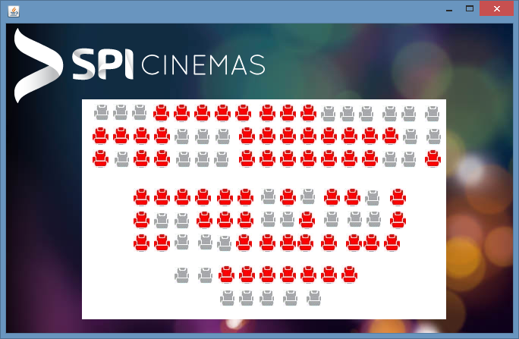

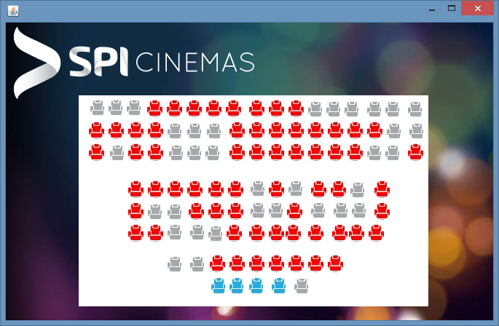

FRAME 10: Card Selection

private void b1ActionPerformed(java.awt.event.ActionEvent evt) {

Card_Details o = new Card_Details();

o.setVisible(true);

this.dispose();

}

private void b2ActionPerformed(java.awt.event.ActionEvent evt) {

Card_Details o = new Card_Details();

o.setVisible(true);

this.dispose();

}

private void b3ActionPerformed(java.awt.event.ActionEvent evt) {

Card_Details o = new Card_Details();

o.setVisible(true);

this.dispose();

}



FRAME 11: Card Details

public static String name;

public static long card;

name = tf2.getText();

card = Long.parseLong(tf1.getText());

int y = Integer.parseInt(tf4.getText());

if((y<=2017)||(cb1.isSelected()==false))

{

JOptionPane.showMessageDialog(null,"Invalid Year or Agreement Check");

}

else

{

try {

String cardnum = tf1.getText();

String cardname = tf2.getText();

int exp = Integer.parseInt(tf4.getText());

int cvv = Integer.parseInt(tf5.getText());

Class.forName("java.sql.Driver");

Connection conn = (Connection) DriverManager.getConnection("jdbc:mysql://localhost/IP_PROJECT","root","password");

Statement st = (Statement) conn.createStatement();

String q = "insert into Card_Details values ('"+cardnum+"','"+cardname+"',"+exp+","+cvv+");";

System.out.println(q);

st.executeUpdate(q);

}

catch (Exception e)

{

System.out.println(e.getMessage());

}

Confirmation o = new Confirmation();

o.setVisible(true);

this.dispose();

}

}

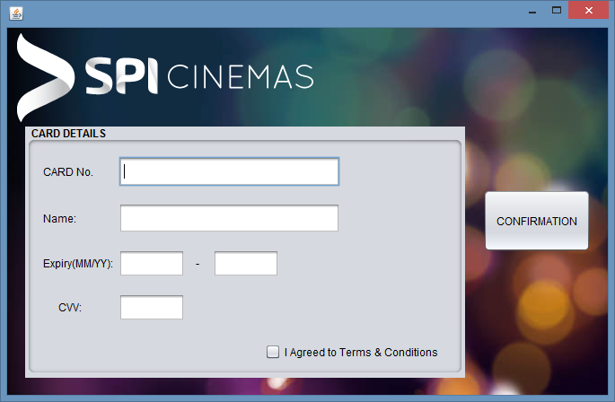

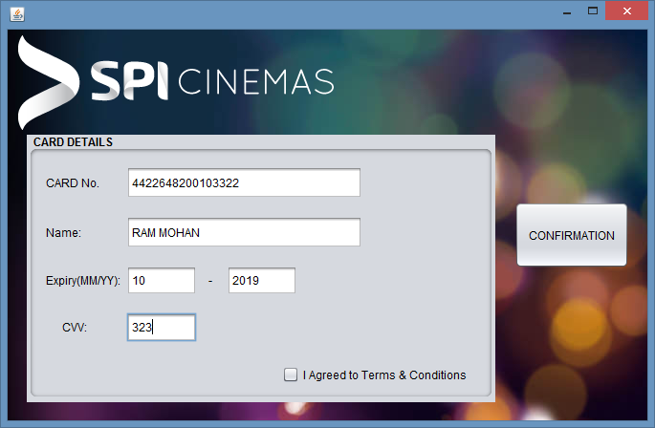

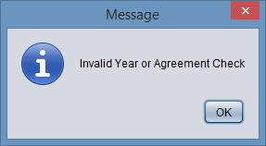

FRAME 12: Confirmation

private void chkoutActionPerformed(java.awt.event.ActionEvent evt) {

Thank_You o = new Thank_You();

o.setVisible(true);

this.dispose();

}

private void confirmationActionPerformed(java.awt.event.ActionEvent evt) {

long num = Card_Details.card;

String z;

int amount = 0;

int a = (Tickets_Dates.a)+1;

l2.setText(""+a);

int b = Movies.movie;

if (b==1)

{

l1.setText("Mersal");

}

else if(b==2)

{

l1.setText("GolMaal Again");

}

else if(b==3)

{

l1.setText("SoLo");

}

else if(b==4)

{

l1.setText("Thor Ragnarok");

}

else if(b==5)

{

l1.setText("Judwaa 2");

}

else if(b==6)

{

l1.setText("Blade Runner");

}

else if(b==7)

{

l1.setText("GeoStorm");

}

else if(b==8)

{

l1.setText("Secret Superstar");

}

else if(b==9)

{

l1.setText("Raja The Great");

}

else if(b==10)

{

l1.setText("DND Mersal");

}

amount = a*150;

l3.setText(amount + ".00");

z = Card_Details.name;

l4.setText(""+z);

l5.setText(""+num);

try {

String movie = l1.getText();

int tickets = Integer.parseInt(l2.getText());

String Amt = l3.getText();

String name = l4.getText();

Class.forName("java.sql.Driver");

Connection conn = (Connection) DriverManager.getConnection("jdbc:mysql://localhost/IP_PROJECT","root","password");

Statement st = (Statement) conn.createStatement();

String q = "insert into Movie_Details values ('"+movie+"',"+tickets+","+Amt+",'"+name+"');";

System.out.println(q);

st.executeUpdate(q);

}

catch (Exception e)

{

System.out.println(e.getMessage()); } }

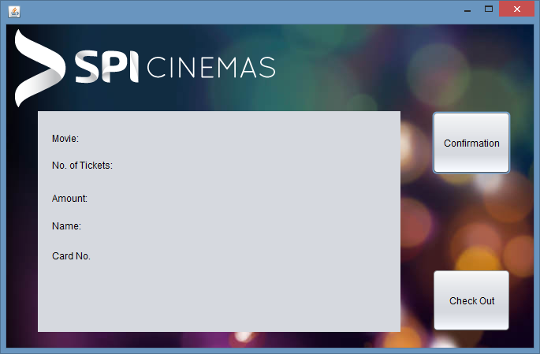

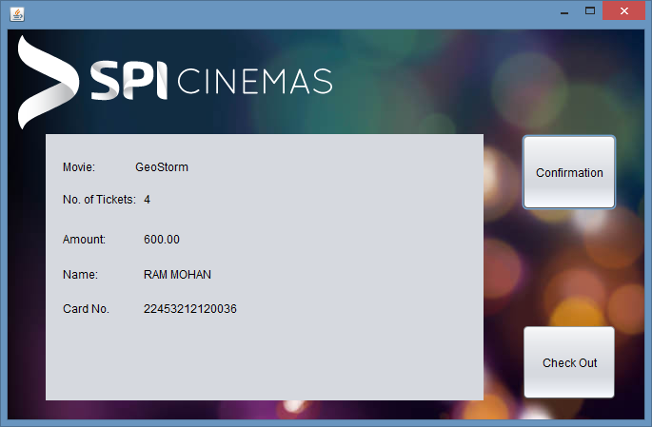

FRAME 13: Thank You

private void jButton1ActionPerformed(java.awt.event.ActionEvent evt) {

System.exit(0);

}

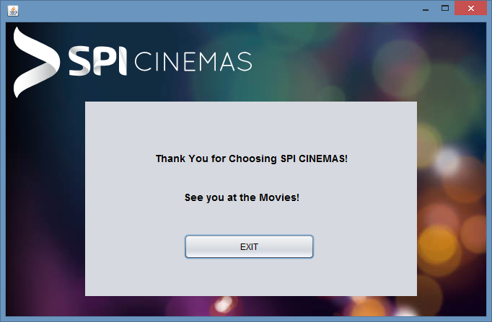

BACKEND DATABASE – MySQL

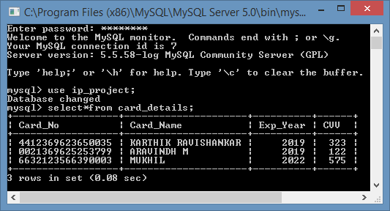

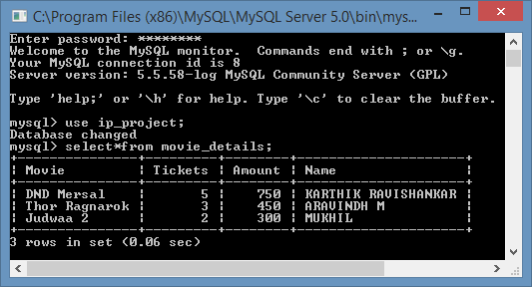

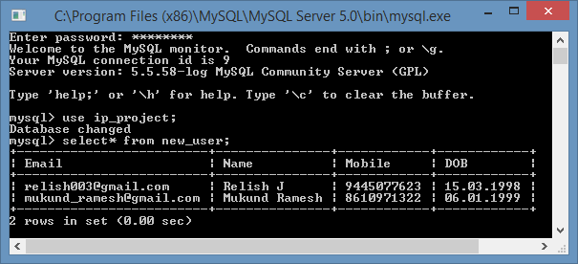

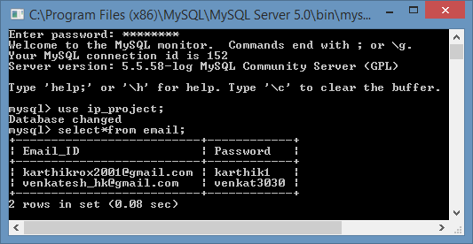

Scope For Further Enhancements

A Button can be added to each frame which enables the user to go to the previous frame.

In the Signup frame Profile Picture can be added if you are a new user.

In the Seat Selection frame the selected seats can also be unselected on further enhancement.

In the final Thank you frame the words can be made to move like a scroller.

Bibliography

- <https://stackoverflow.com/>

- <http://www.codejava.net/>

- Class 12 IP – Sumita Arora Text Book

- Class 12 IP – CBSE Text Book

Developers

- KarthiK R

- Pranavaram A

- Chandramouleesvar V

